Subramani

20/11/2024

PL/SQL Task2

Triggers and Cursor

use temp_DB;

create table emp (

emp_id numeric primary key,

emp_name varchar(50),

dep_id numeric,

constraint fk_dept foreign key (dep_id) references department(department_id)

);

create table department(

department_id numeric primary key,

dept_name varchar(50),

emp_count numeric

);

insert into department values(1,'ES',2),(2,'DNA',1);

insert into emp values (101,'Subramani',1),(102,'Hari',2),(103,'sankar',1);

select * from emp;

select * from department;

-- When inserting the employee details in emp table automatically trigger trigg the values

-- and update the values in department table emp_count columns

delimiter //

create trigger get_trigger

after insert on emp

for each row

begin

update department

set emp_count = emp_count+1

where department_id = new.dep_id;

end;

//

insert into emp values(110 , 'sedhu', 2,33000);

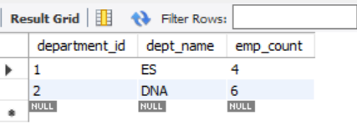

-- create a trigger that display the count of rows after inserting a new record to

-- a employee table before\after insert

create table log_details(

id int auto_increment primary key,

count_rows int,

times datetime default current_timestamp

)

delimiter //

create trigger get_rowcount

after insert on emp

for each row

begin

declare row_counts int;

select count(*) into row_counts from emp;

insert into log_details (count_rows) values (row_counts);

end //

insert into emp values (109, 'balaji',2 , 34000);

select count_rows from log_details ;

select * from emp

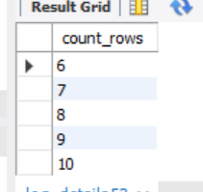

-- create a trigger that display the count of employees whose salary got updated after update?

alter table emp add column emp_salary numeric;

select * from emp;

update emp set emp_salary = '10000' where dep_id = 1;

update emp set emp_salary = '20000' where dep_id = 2;

create table update_Demo(

id int auto_increment primary key,

counts numeric,

times datetime

);

delimiter //

create trigger get_salaryDemo7

after update on emp

for each row

begin

declare update_count int;

if new.emp_salary != old.emp_salary then

set update_count = (

select count(emp_id) from emp where emp_salary != old.emp_salary);

insert into update_Demo (counts,times) values (update_count,now());

end if;

end //

update emp set emp_salary = '9800' where emp_id = 101;

select * from update_Demo;

select count(times) as update_counts from update_Demo group by times ;

select * from emp;

-- create a view that displays the details of employee from chennai and tn team

alter table emp add column location varchar(50);

insert into emp value (115,'arun',2,35000,'Chennai'),(116,'revi',1,55000,'salem'),(117,'arun 2.o ',2,15000,'Chennai')

create view employee_view as

select * from emp e

join department d on e.dep_id = d.department_id

where e.location = 'Chennai' and d.dept_name = 'DNA';

select * from employee_view;

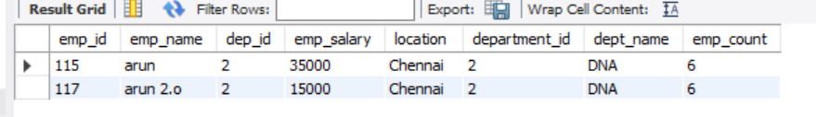

-- create a view that displays the details of products electronics and price <1000

select * from product;

create view product_views as

select * from product where qty < 20 and price <= 100

select * from product_views;

